**Deployment:**

1. **Create Release Notes**
   1. Get from developers info regarding changes included in the release.
   2. Duplicate one of the release notes under: **svn\Releases\trunk\Release** **Notes\** and change it according to info from above step. **Hello how are you can you see the text?**
2. **Prepare list of non DB changes**
   1. **From date of current deployed Ear to date of new ear to be deployed**
   2. **Non DB changes are in:** 
      1. **svn\nw-development\<Relevant tag or trunk>\Docs\changes.txt**
   3. **Prepare changes locally**
      1. **Property changes done in backup of properties from facility.**
      2. **Files and folders to be added should be prepared.**
3. **Rest of the changes should be listed.**
4. **Upload the new Ear file to the server**
   1. Upload to: Desktop\NW\Current
5. **Backup current Ear and provide new Ear - WAS machine**
   1. Make sure that **current deployed Ear** is under: **Desktop\NW\Current**
6. **Backup DB - DB machine**
   1. 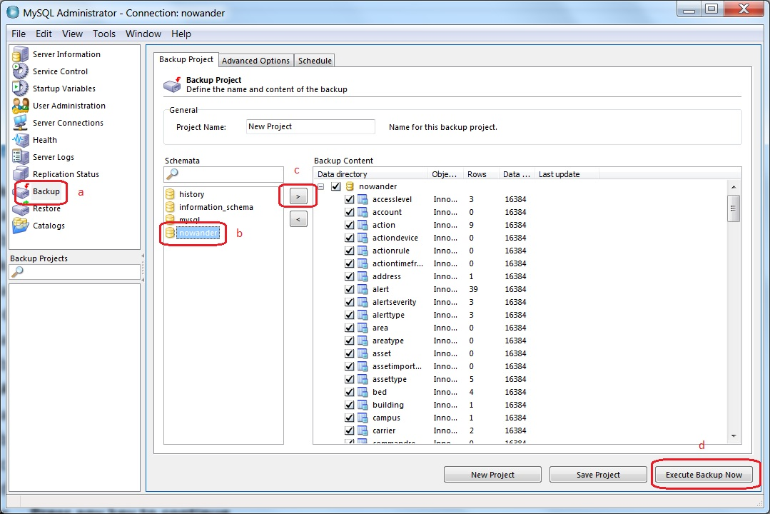
   2. Open **MySQL Administrator**
   3. Select **Backup** on the left
   4. Select **New Project**
   5. Select **nowander** schema
   6. Click the “**>”** button and make sure all tables are listed under “**Backup Content**” on the right.
   7. Click “**Execute Backup Now**” on the bottom right.
   8. 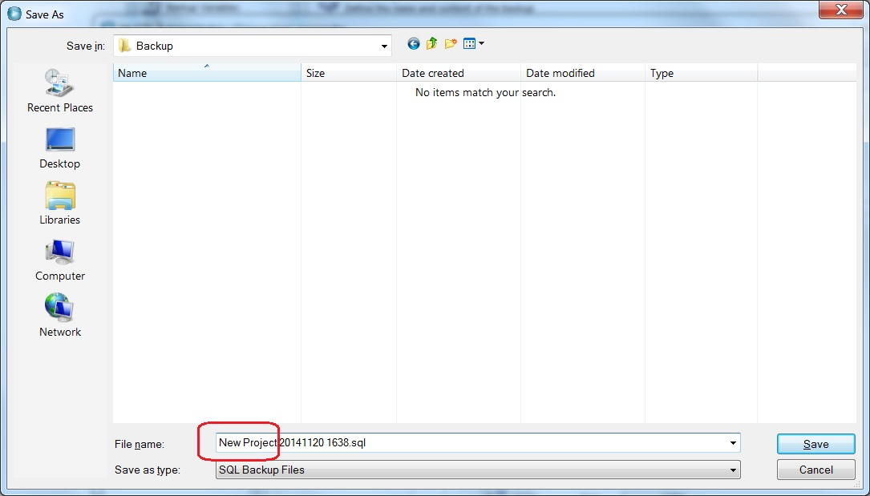
   9. Change the file name to “**NW yyyy-mm-dd hhmm**” where **yyyy** is current year, **mm** is current month, **dd** is current day of month, **hhmm** is hour and minutes, and save it under **Desktop\NW\Backup**
   10. Repeat steps e to i for the **history** database, replacing file name part **NW** with **History**.
   11. Confirm the size of the backup files are as expected.
7. **Configure daily backups of nowander and history schemas in C:\Nowander\backup on DB machine.**
8. **Backup Properties files (**If there are changes in Properties files**)**
   1. WAS machine
      1. C:\nowander\nw.properties
      2. C:\nwmanager\nwmanager.properties
   2. Adapter machine
      1. C:\nowander\nw.properties
      2. C:\logitagadapter\logitagadapter.properties
      3. C:\visonicadapter\visonicadapter.properties
9. Edit **C:\Script\global\global.py - WAS machine**
   1. Set “**APP_2_INSTALL**” value to **new Ear name** without extension.
   2. Set “**APP_2_UNINSTALL**” value to **current deployed Ear** name (NWEar or Starts by NWEar) as it appears in WAS admin:
   3. 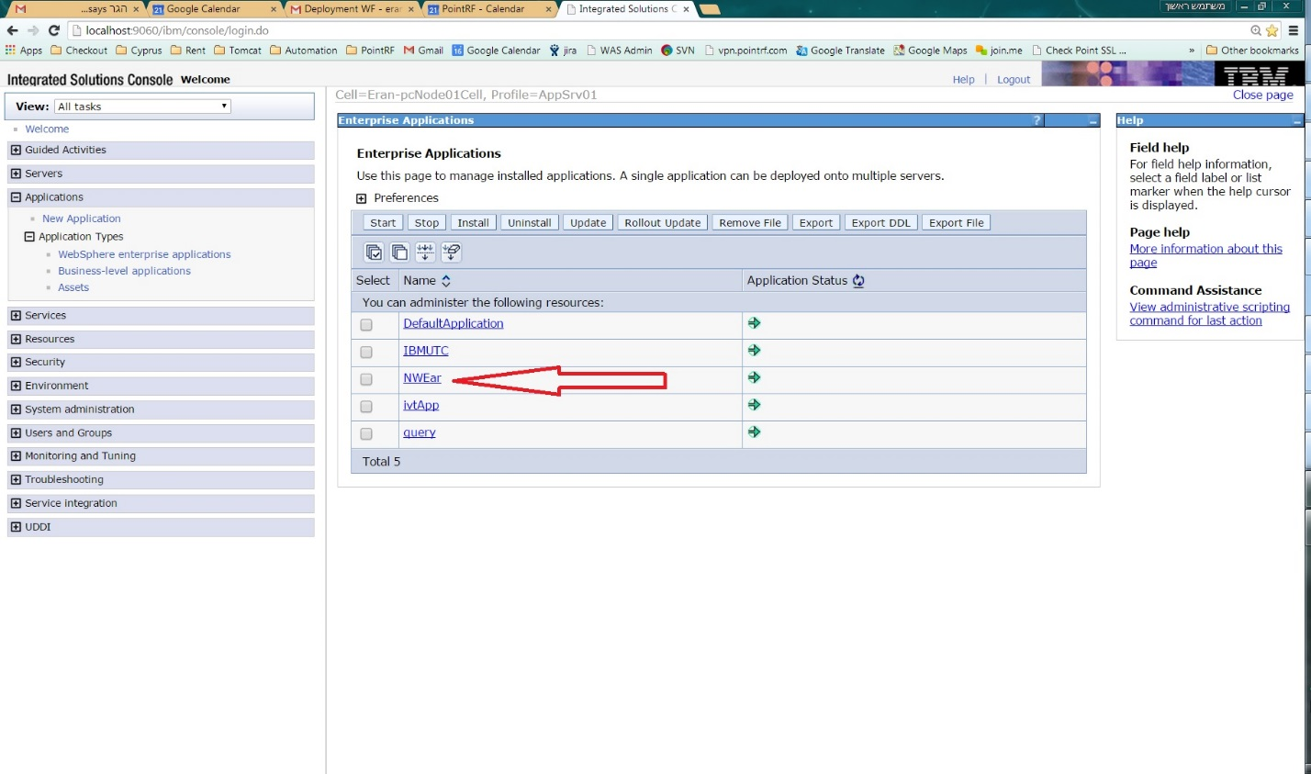
10. Check that latest **FeedbackAdapter** and **VisonicAdapter** are being used and not Tools and Connector **- DB machine (2 machines setup), or adapters VM (1 machine setup)**
    1. svn\Releases\trunk\NWFeedbackAdapter
    2. svn\Releases\trunk\VisonicAdapter
11. **Check for non DB changes**
    1. **C:\SVN\<Relevant branch, tag or trunk>\Docs\changes.txt**
12. **Stop FeedbackAdapter and VisonicAdapter**
13. **If ELC firmware** **has been upgraded to the latest 1.3.40**
    1. **Backup current ELCWrapper.DLL**
       1. C:\Windows\
    2. **Install the latest ELCWrapper.DLL**
    3. Check the ELC firmware from the NW page System Administrator / Device Management
       1. Click on button "Scan for Devices"
       2. Click on Discover
       3. Every ELC has type "Elpas RF RDR", check the correspondent column Version
    4. Copy **latest ELCWrapper.DLL** from: svn\Releases\trunk\NoWander\
    5. Paste **latest ELCWrapper.DLL** in:
       1. C:\Windows\
       2. C:\Windows\System32\
       3. C:\Windows\SysWOW64\
    6. Run: **Google Drive\Install\WAS\ELCWrapper\Setup1.msi**
    7. Run: **Google Drive\Install\WAS\ELCWrapper\WinPcap_4_1_3.exe**
    8. Set property in C:\nowander\nw.properties: **ELCManager.GetLPDB=false**
14. **Uninstall current Ear, Stop server, Clear logs, Start server, Install new Ear, Start new Ear, List applications - WAS machine**
    1. Run: **C:\Script\Uninstall_Current_App_Install_New_App.bat**
    2. Ignore the first “**Press any key to continue** **. . .**” message. Let the script wait 5 seconds and continue.
    3. Respond to any additional “**Press any key to continue** **. . .**” messages by pressing any key.
    4. Make sure that new app is listed by the end of the script.
15. **Start NW Server (if not started automatically)**
    1. Nwmanager -> System Administration -> System Status
16. **Check error logs - WAS machine**
    1. C:\nowander\logs\error.log
    2. Profile\logs\server1\SystemErr.log
    3. Profile\logs\server1\SystemOut.log
17. **Check for correct version number**
    1. <http://localhost/nwmanager/login.jsp>
    2. 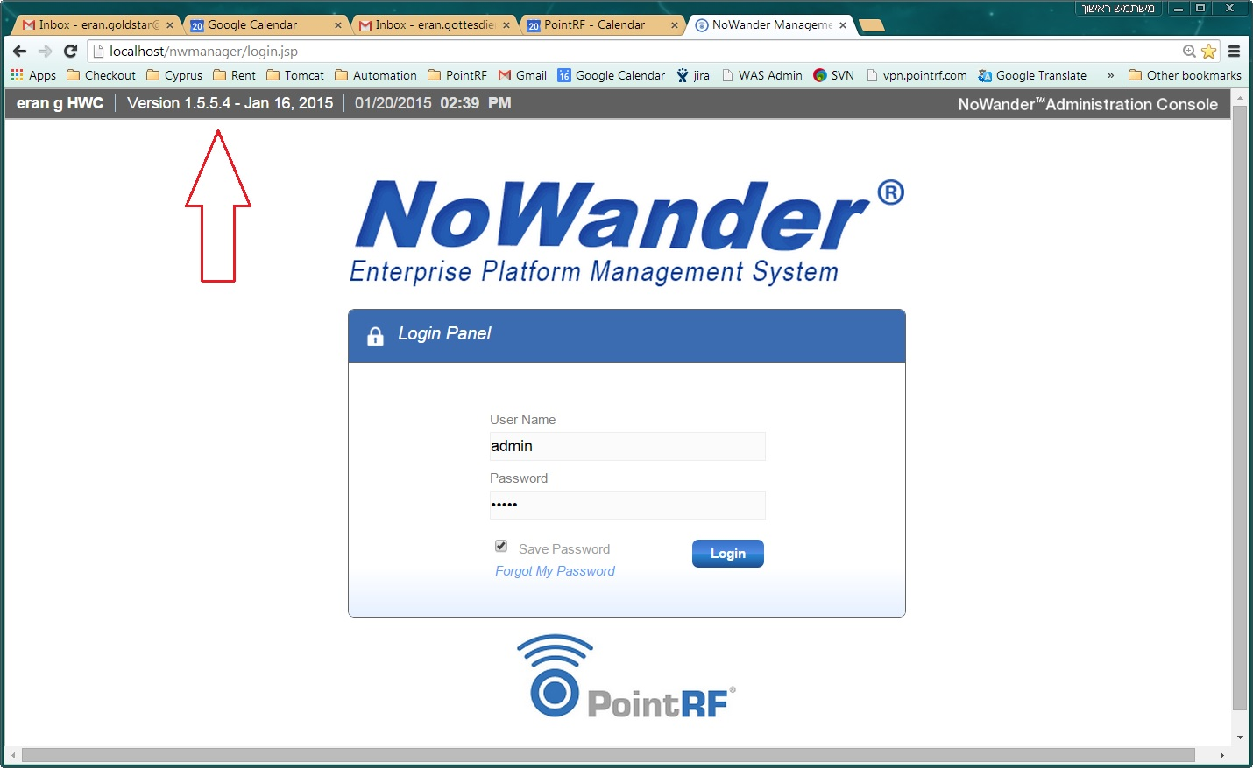
18. Check for database changes
    1. <http://localhost/nwmanager/login.jsp>
    2. 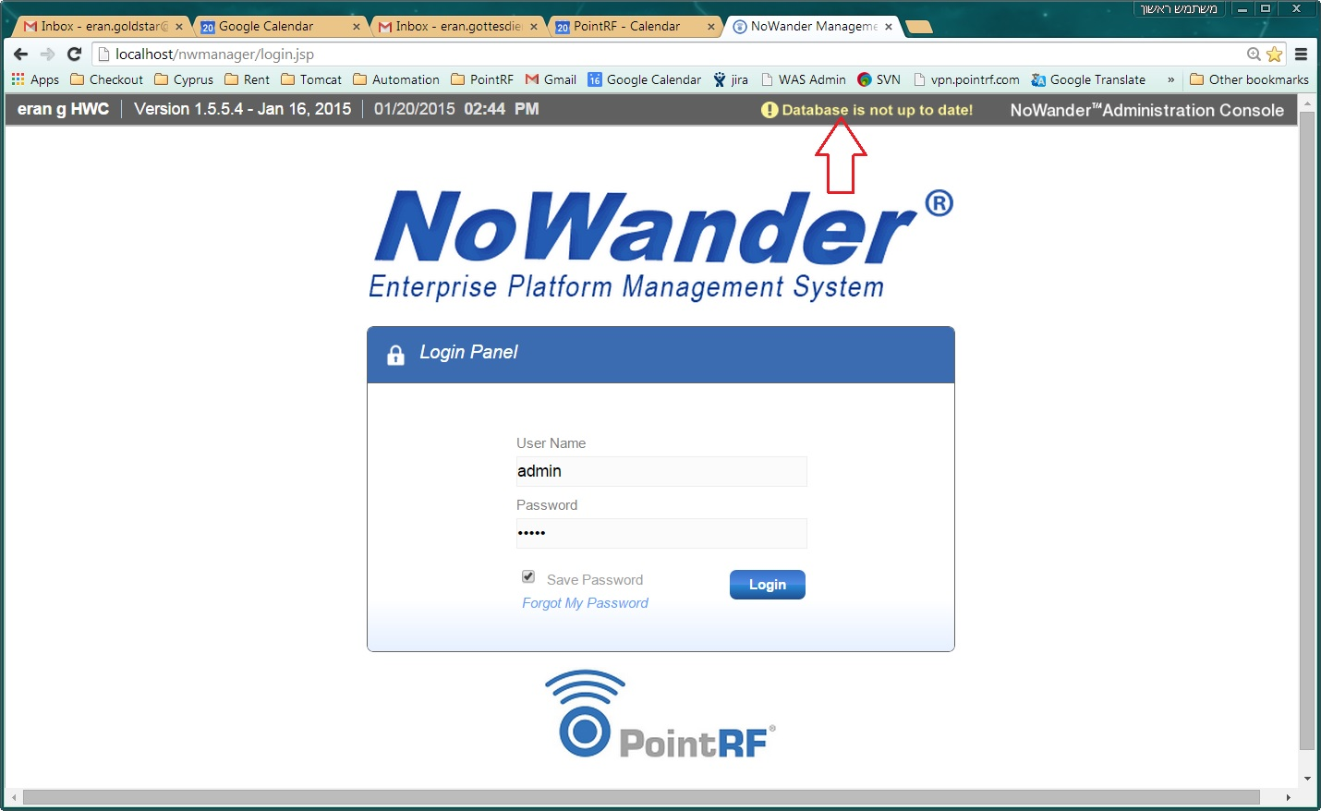
    3. If “Database is not up to date!” message appears
       1. Browse to: <URL:localhost:8080/nwmanager/UpdateDBLogin.jsp>
       2. Login
       3. Click “Update Database” button and wait for success message.
       4. 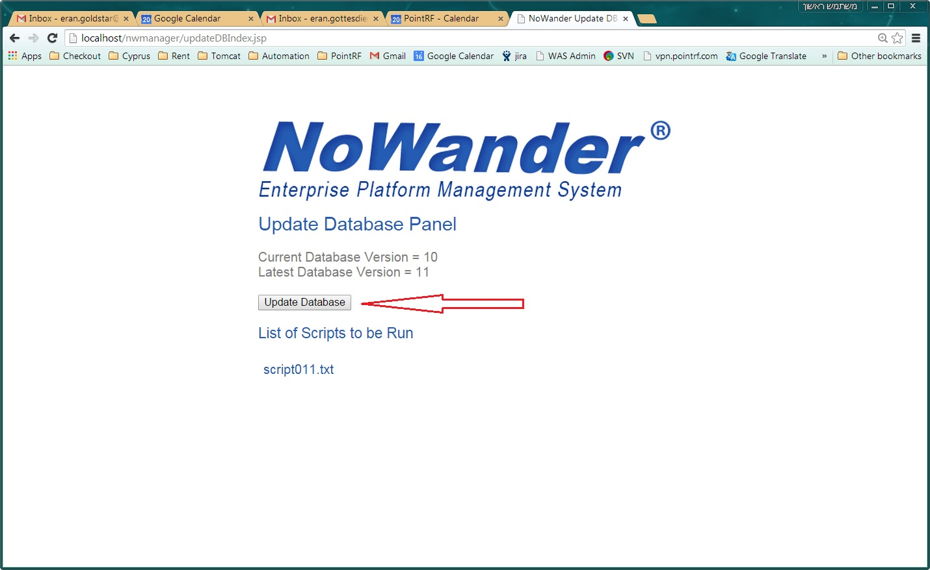
       5. 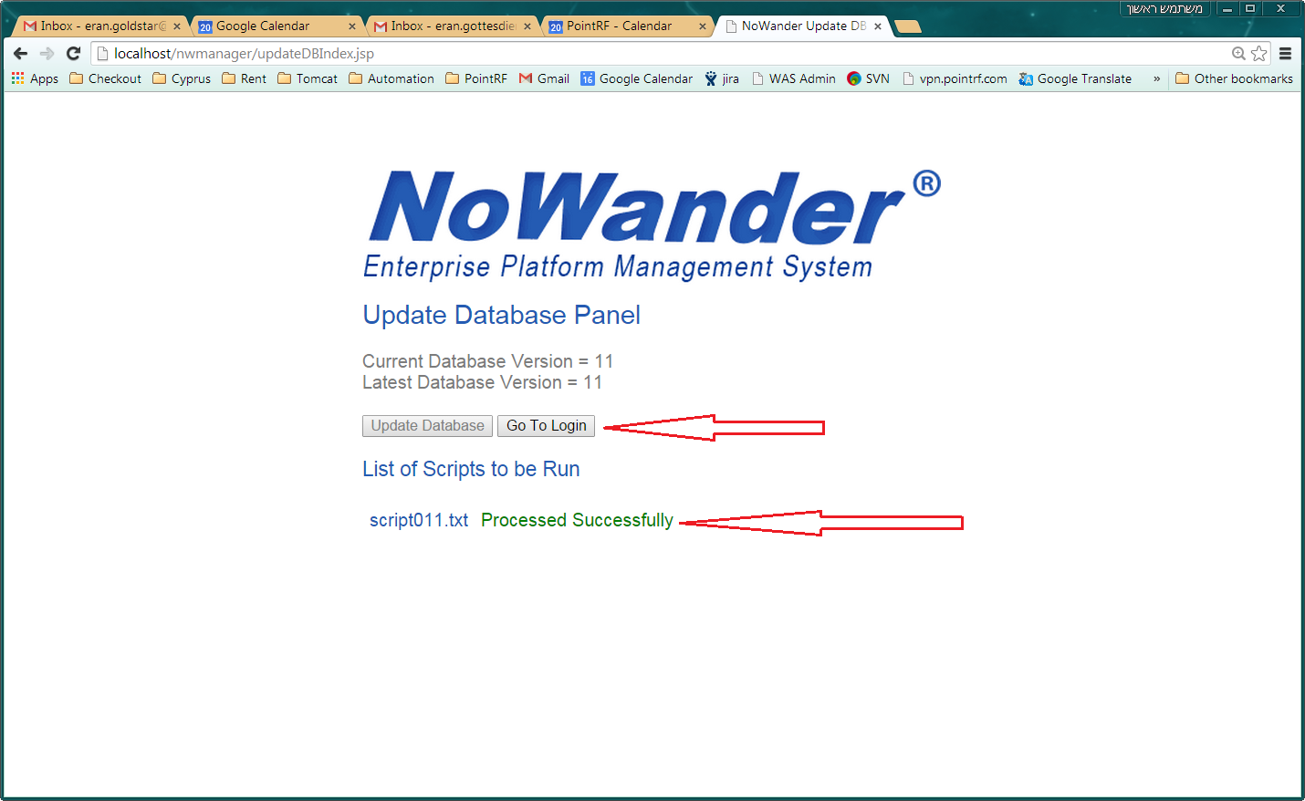
       6. Database errors at this point (if any) will have to be fixed manually
       7. If there are no Database update messages - Click “Go To Login” button and Login to app.
19. Check the server is running in the UI,
    1. **System Administration > System Status**
20. **Start FeedbackAdapter and VisonicAdapter - DB machine (2 machines setup), or adapters VM (1 machine setup)**
21. Move **previous Ear** from **Current** folder to **Last** folder **- WAS machine**
    1. Copy **Desktop\NW\Current\<Current Ear>**
    2. And paste it under **Desktop\NW\Last**
    3. Delete **Desktop\NW\Current\<Current Ear>**
22. Update **SVN\Tech\Dev\Facility Tech Details.xlsx** and commit
23. Email all.

**Rollback:**

1. **Backup current Ear and provide Ear to be rolled back - WAS machine**
   1. Make sure that **current deployed Ear** is under: **Desktop\NW\Current**
   2. Place the **Ear** to be rolled back under: **Desktop\NW\Current**
2. Edit **C:\Script\global\global.py - WAS machine**
   1. Set “**APP_2_INSTALL**” value to the name of the **Ear** to be rolled back.Without extension.
   2. Set “**APP_2_UNINSTALL**” value to **current Ear name.** Without extension.
3. **Stop FeedbackAdapter and VisonicAdapter - DB machine (2 machines setup), or adapters VM (1 machine setup)**
4. **Stop WAS - WAS machine**
   1. Run: **C:\Script\Stop_Server.bat**
   2. Wait until “**Press any key to continue** **. . .**” message is displayed.
   3. **Press any key to continue**
   4. **Wait until the java process disappears from Task Manager “Processes” Tab.**
      1. **If it doesn’t disappear after a minute – Kill it.**
5. **Drop nowander and history database schemas**
   1. 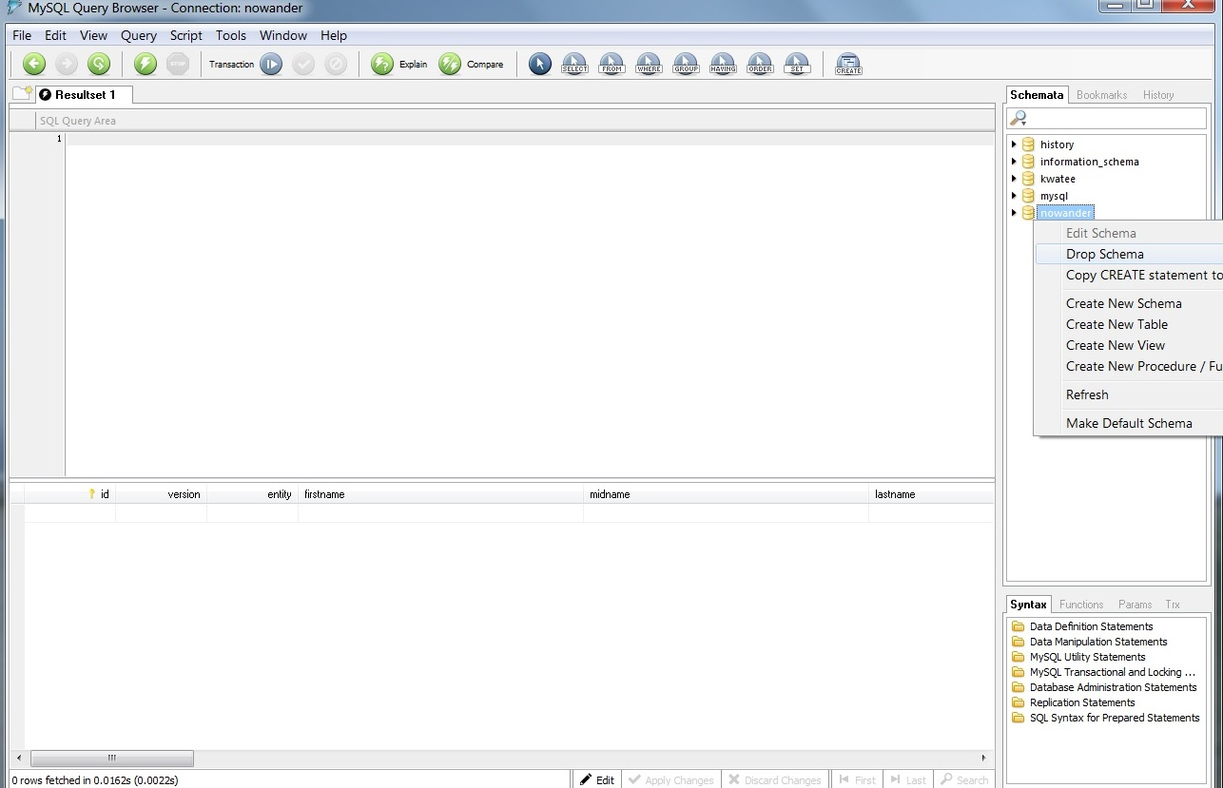
6. **Rollback nowander and history DB schemas - DB machine (2 machines setup), or WAS and DB machine (1 machine setup)**
   1. 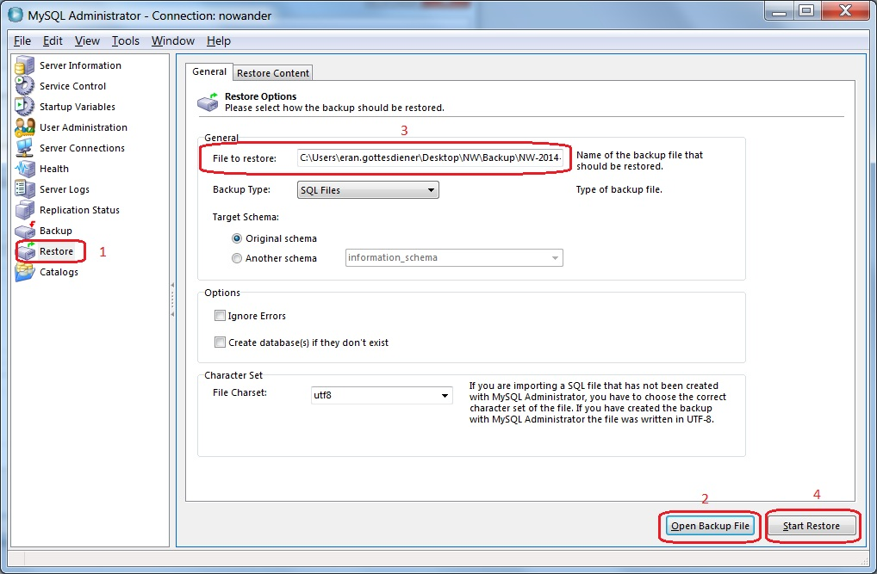
   2. Open **MySQL Administrator**
   3. Select **Restore** on the left
   4. Click the “**Open Backup File”** button on the bottom right.
   5. Select the **backup file** that was created on the **Backup DB** step of the Deployment.
   6. Click the “**Start Restore”** button on the bottom right.
   7. 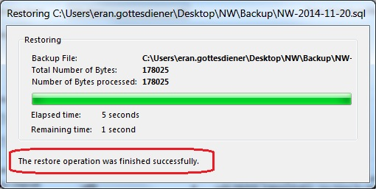
   8. Wait until the above “success” message appears.
7. **Rollback ELCWrapper.DLL if needed**
8. **Rollback non DB changes**
9. **Restart MySql - DB machine (2 machines setup), or WAS and DB machine (1 machine setup)**
   1. 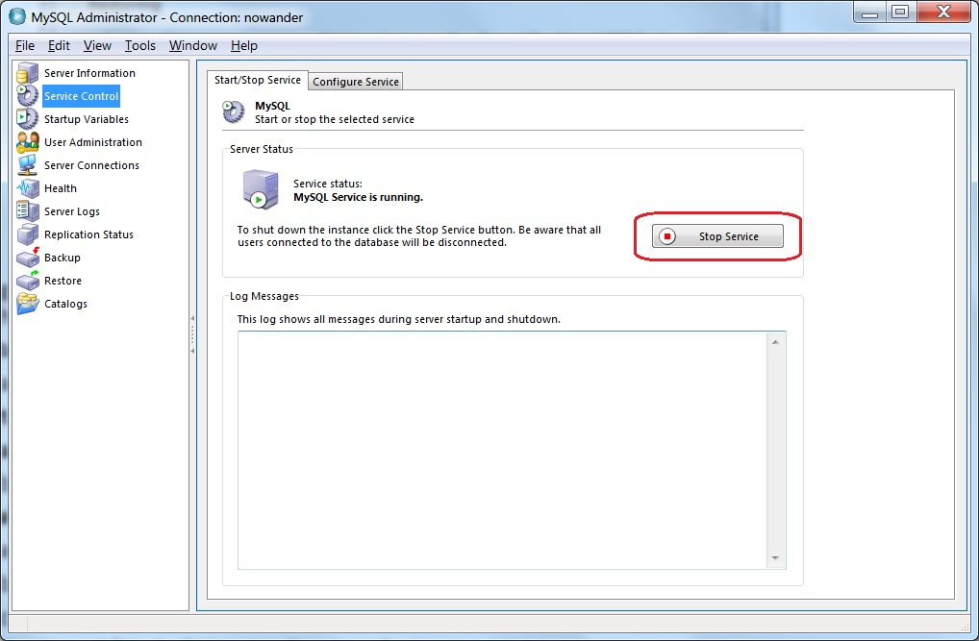
   2. Open **MySQL Administrator**
   3. Select **Service Control** on the left
   4. Click the “**Stop Service”** button on the right.
   5. Wait until the “**Stop Service”** button changes to “**Start Service”**
   6. 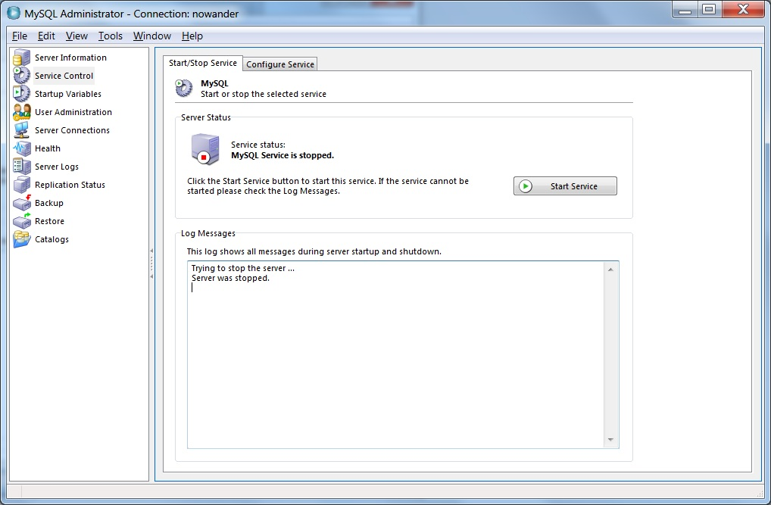
   7. Click “**Start Service”**
   8. Wait until the “**Start Service”** button changes back to “**Stop Service”**
10. **Start WAS - WAS machine**
    1. Run: **C:\Script\Start_Server.bat**
11. **Repeat steps 10 of Deployment section (Uninstall_Current_App_Install_New_App.bat) to end of section.**